Subject: Intra-Division Box Card Design for Michigan Agencies
Functional Area: Operations Adoption Date:

Category: Guideline Revision Date:

Approved By: Chief Adam Carroll, MI-MABAS President Page:

Table of Contents

Section Page
Section 1 - Overview 2
Section 2 - The Planning Process 2
- Agreements
- Resource typing
- Inventory internal resources
- Share resource lists with division members
- Determine incident needs
- Determine response times and distance
- Agree upon format
- Inventory pages
Section 3 - Box Alarm Card Definitions 5
Definitions of the box card 5
Section 4 - MI-MABAS Dispatch Communications Committee 8
Recommended changes 8
Guideline definitions 9
Section 5 - Box Card Numbering System 12
Incident Category Number 13
Section 6 - Out of Division BOX Cards 15
Scramble vs Standard Response 15
Section 7 - Approval of new or changed box cards 16
Appendix A Box Card Templates and Examples 17
Example Box Card Structure Fire Hydrant 17
Example Box Card Confined Space 18
Example Box Card Rope Rescue 19
Example Box Card Target Hazard 20
Section 1: Overview

The development of Box Cards is essential to an agency’s success. They form the foundation for all responses and serve as a key tool for training and orienting personnel to the MI-MABAS concept.
MI-MABAS does not dictate how agencies must develop their Intra Divisional Box Cards. These cards are critical for both the communities served and the agencies and dispatchers who rely on them.
By outlining pre-planned responses, Intra Divisional Box Cards provide a clear framework that helps dispatchers deploy and track resources efficiently and effectively.

Section 2: The Planning Process

Common terminology must be agreed upon as the inventories are compiled. For example, in some communities, an ambulance is called a rescue squad, a truck is called a ladder, and so on. MI-MABAS has a common terminology policy to follow that divisions can adopt for their centers.

As with rescue squads, “Quints” are a common source of debate when designing run cards. If a quint has the necessary equipment required for engine work, the unit should be considered an engine. Likewise, if the quint primarily has truck equipment, it should be considered a Ladder / Aerial.

Inventory Internal Resources
Before a division can begin developing Box Cards, each community must inventory its internal resources. It is important to consider staffing as well as the equipment itself. For example, a community may have a truck and several engines; however, the daily staffing of that community may not allow for both units to be sent on an incident.

The division must take the time to have each department involved in developing an equipment inventory and the maximum number of units the community can send to a specific incident at stressful or thin times. A general rule of 80%-20% should be

considered. The rule allows only 20% of a community’s resources to be offered as mutual aid resources, leaving 80% at home to protect their community.
In some cases, due to staffing shortages, a department may rely on a neighboring agency to provide a full station response. This is an acceptable and, in some communities, even a common practice given ongoing challenges with maintaining adequate staffing levels.
However, it is essential that both the requesting and responding agencies collaborate closely to ensure continued coverage for both communities. When one agency is fully committed to another’s jurisdiction, both communities may be left without immediate fire/rescue protection if not properly coordinated..

Share Resource Inventory Lists with Division Members
Once each community has developed its resource inventory list, these lists must be made available to each division member. This allows communities to identify resources that are otherwise unknown to division members. It also indicates the capabilities of the communities. The goal is to build response packages based on true division member capabilities.

Determine Incident Needs
Box alarm cards must be developed based on community risk assessments. For example, a community with very close buildings and multiple exposures will have to address box cards differently than a community with large setbacks. Target hazards and any other special needs (lack of ladder or aerial resources) must also be considered. Many communities already have this information in pre-fire plans, contingency plans, and regional planning documents.

Determine Response Times and Distance
When setting up box cards, consider response times and routes of responding units. The idea is to draw some resources from multiple communities instead of many resources from a few. This allows those agencies to provide fire protection to their own community still and not put all their resources on their neighbor. Response times must be considered to ensure there is not a significant gap in available units.

Agree Upon a Format
The division should agree upon one format or program for developing the cards. The MI MABAS leadership has agreed to use a format found on the MI-MABAS website: https://mabasmi.org/red-center/ at the bottom of the RED Center tab.

Although this may not be the best format, others have found ways to use Microsoft Excel to do a better job. It is essential that the columns labeled remain the standard and the rows labeled remain the standard with the box card development. The looks and manipulation otherwise can be altered except for the columns and rows with the current labels.

The division members must agree upon a common numbering system. A standard card numbering system can provide a wealth of information to outside agencies. More information can be found in section six. The uniform numbering system provides three basic pieces of information:
- The municipality identifier – generally the FDID number assigned to the agency.
- The box card area - generally a letter or number referencing a map used in the dispatch center outlining the response area.
- The type of incident – a number is assigned to the kind of incident being used.

Section 3: MI-MABAS Box Alarm Card Definitions
(in order of appearance on cards)

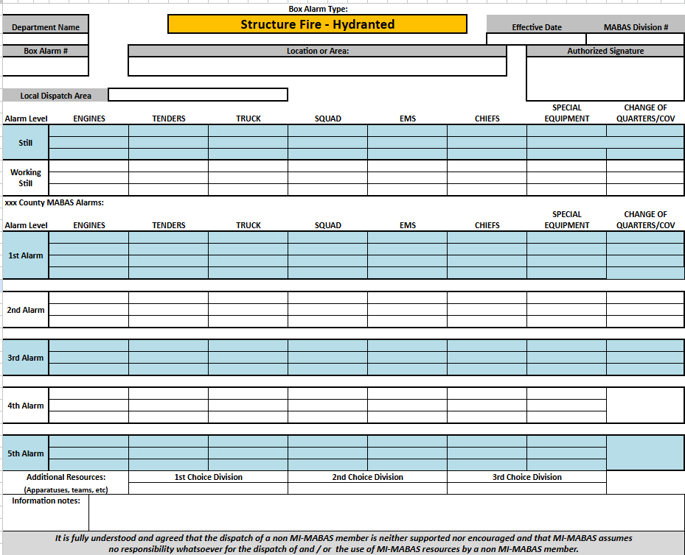

Cell title Definition
Department Name The name of the Fire Department issuing the card
Box Alarm Type The type of emergency situation covered by the card
Effective Date The date the use of the card is authorized to begin by the issuing
department
MABAS Division The Division number in which the FD holds a membership
Box Alarm Number The number for the card designated by the FD. The numbering
system should be coordinated with the other members of the division.
Location or Area This can be a single location or building, a geographical portion of
the department's area or response or the entire area of response.
Authorized The signature of the Fire Chief of the department issuing the card.
Signature
Local Dispatch This portion of the card is intended to show the response to any
Area units before the Box Alarm level. The primary responding units will
be those of the local and possibly outside departments, generally using audio-aid agreements.
Alarm Level This refers to the designation given by the issuing department for
responses to this location before the Box Alarm level. This allows for the two levels before the Box Alarm level. The name of the alarm levels will be based on local preference. Includes the names of the departments that are omitted to provide this type of equipment at the alarm level designated.
Engines Based on MI-MABAS designations
Tenders/Tankers Based on MI-MABAS designations
Ladder/Aerial Based on MI-MABAS designations
Squads Based on MI-MABAS designations
Chiefs Based on MI-MABAS designations
Special Based on MI-MABAS designations
MABAS Box Alarm This portion of the card is intended to show the response for any
units starting at the Box Alarm level. The MI-MABAS mutual aid agreements cover these responses.
Alarm Level This refers to the Box Alarm, 2nd Alarm, 3rd Alarm, etc., to the
ultimate level deemed appropriate by the department to handle possible emergencies. Includes the names of the departments committed to providing this type of equipment at the designated alarm level.
Change of This lists the station(s) that will house units from neighboring
Quarters departments. The specific units specified on each level will
respond to other emergency calls for the duration of the original call unless they are asked to move up to the scene.
Special This area is reserved for any information that will allow the Instructions telecommunicators handling the radio communications for the
incident to access specific information to assist responding units quickly. Some of these could be the address of the change of quarter’s stations, special contact numbers for key department members, and numbers for departments that are due to respond that may have special contact requirements.
Inter-Divisional When an incident commander needs additional resources Requests from neighboring counties brought to the incident but may not want
to use the next alarm level of resources. Or The incident has exhausted all the resources on the card. They can request specific resources and the dispatcher will go to the 1st choice, 2nd choice, 3rd choice divisions to find those resources.
Out of Division An Out of Division Request is activated when all companies have Request been dispatched on the specific Box Alarm Card, and additional
companies are required for a large-scale incident. During an Out of Division Request, speed of response is essential. The Division providing companies determine which departments and units respond based upon an organized predetermined Out of Division Strike Team or Task Force response cards. If an agency does not know how to obtain these resources, a phone call to the MI-MABAS RED Center 734-477-6400 will assist in this response.
Strike Team A set number of resources of the same kind and type with an
established minimum number of personnel. Strike Team packages are identified in the MI MRP Handbook found on the website to be downloaded.
Task Force A combination of resources assembled to support a specific
mission or operational need. All Task Force packages are identified in the MI MRP Handbook found on the website to be downloaded.

Section 4: MI-MABAS Dispatch Communications Committee

Recommended Practice - MI-MABAS Box Card Design

Purpose
To coordinate the design of MI-MABAS Box Alarm Cards for both new and existing MABAS Divisions, using a single standardized template that includes all required dispatch information and ensures the Box Alarm is easily understood by emergency personnel and telecommunicators

Scope
This recommended practice applies to all new and existing MI-MABAS Divisions wishing to use one template throughout their division. It incorporates the traditional style card with recommended changes designed to make dispatching MI-MABAS Box Alarms easier for telecommunicators and emergency service personnel.

Background
MI-MABAS is experiencing rapid growth throughout numerous locations, with many new divisions forming. Many of these new divisions have limited internal experience to draw upon in developing box alarm cards and have requested assistance
with the design process and a generic box alarm card in an electronic format. The MI-MABAS Dispatch Communications Committee was tasked with this responsibility at the MI-MABAS Executive Board in 2017. The MI-MABAS Dispatch Communications Committee has developed standard templates containing all the required elements to design a MABAS Card on the MI-MABAS website. The committee also created a MI-MABAS 101 class for fire dispatchers to teach telecommunicators the responsibilities of being a primary or secondary dispatch center managing MABAS cards for divisions.

Recommended changes
To make it easier for telecommunicators and emergency service personnel to understand and reduce the number of errors during alarm dispatch, Divisions can recommend these changes:

- Some departments may bring “Change of Quarters” companies into their stations and leave them there to handle further calls in their jurisdiction throughout all the alarms. Other departments may bring “Change of Quarters” companies into the stations and move them to the scene on the next level of alarm. These are both allowable alternatives.
- “Change of Quarters” companies will be placed in the column for “Change of Quarters,” the station where they are expected to go will be placed in parentheses. The address and directions to that station should be placed in the “Information” section at the bottom of the card.
- The card style on the MI-MABAS website does not limit the number of alarms each department can have on its card. Each division can add as many alarms per card as desired by adding additional rows.
- It is recommended that the last alarm level be reserved for “Interdivisional Request,” which should include the “1st CHOICE, 2nd CHOICE, and 3rd CHOICE” of which divisions to call when extra equipment is needed.
- The bottom of the card should be kept for addresses for the change of quarter’s stations and other pertinent information or instructions for the dispatchers to find. It should never have a task for a dispatcher to complete at any given alarm level. Tasks should be on the alarm level if the IC needs something completed by the dispatcher.

Guideline
Each box alarm card should include the following: The top section should include “Department Name, Box Alarm Type, Effective Date, MI-MABAS Division #, Box Alarm #, Location or Area of Alarm, and Authorized Signature.” There will be no other changes to this area.

The next section is the “Local Dispatch Area,” which will be the responsibility of the local dispatch authority. This is not a MABAS area and may include: “Still, Full Still, Working
Still, Etc.” This area may be any number of rows you choose for your division or department.

Definitions
Still - A "still alarm" in firefighting terminology refers to a fire alarm indicating a fire or emergency requiring a single station response, but not necessarily a full-scale alarm

Full Still - A "full still alarm" in firefighting terminology refers to a fire alarm that is a predetermined response or multiple stations from the fire department, often a basic level of resources kept at the level of the agency having authority of the jurisdiction.

Working Still—In firefighting terminology, a "working still alarm" indicates a fire that requires a full initial response and potentially more resources, as opposed to a simple "still alarm."

Automatic Aid or Full Alarm of Full Assignment - In firefighting terminology, a "full alarm" or "Automatic Aid" or Full Assignment signifies a severe fire that requires a substantial response, involving many firefighters and resources, and is determined by the number of units and firefighters dispatched.

Box Alarm Level—In firefighting, a "box alarm level" refers to a predetermined, progressive system for dispatching additional resources (fire trucks, ambulances, etc.) to a fire or incident, escalating from a standard initial response to a larger, multi-alarm response.

Cards are to be read from left to right dispatching departments. Departments will be sent to the scene unless in the “Change of Quarters” column. All agencies are to be read out loud across the dispatch radio so agencies understand who is doing what and responding to where, such as Change of Quarters.

The number of alarm levels is left to the individual fire department. MABAS starts at the “Box Alarm Level” and proceeds to the “2nd Alarm Level, 3rd Alarm Level, 4th Alarm Level, 5th Alarm Level” and may continue through any number of levels that are put on the cards.

The last alarm level is reserved for “Additional Request,” and that level should include rows of resources for extra equipment as needed.

To eliminate clutter and confusion on box alarm cards, the following information should not be included on the front of box alarm cards:

- Telephone numbers for responding agencies. The MABAS System is designed to use radio alerting to notify departments due to respond, including departments within adjacent MABAS divisions.
- Area for Response District Maps. If a department desires to include maps for the response jurisdiction, change of quarters, station locations, etc., this information may be included on the back of the box alarm card.
- Shaded Areas or Color Copies. The use of shading or color other than black is discouraged because various features on box alarm cards may limit the readability of the document after photocopying.

Section 5: MI-MABAS Box Card Numbering System

The purpose of having a Box Card Numbering System is to address uniformity in
the numbering of the box cards among division members. Each division should
agree to one uniform method, which is only a recommendation.

This numbering system has three specific parts to the box card number.
The parts consist of
- The municipality identifier - generally the FDID number assigned to the agency
- The box card area - generally a letter or number referencing a map in the dispatch center.
- Incident Category Number - a number assigned to a specific type of response.
The parts of the box numbering system are as follows, for example:

FDID # Fire area Type of Incident
Example 8105 -1 -2

Fire department identifying number
The box card number begins with a unique fire department identifying number (e.g. above 5). Many fire departments already have these numbers established and in use. The examples below are from Washtenaw County:
Department name FDID#
Ann Arbor City FD 8101
Ypsilanti City FD 8102
Augusta Twp FD 8103
Saline City FD 8104
Dexter Area FD 8105
Chelsea Area FD 8106
Manchester Area FD 8107
Northfield Twp FD 8108
Salem Twp FD 8109
Pittsfield FD 8110
Superior Twp FD 8111
Ann Arbor Twp FD 8112
Milan Area FD 5828

Fire area Card Number
Each fire department currently has fire districts or geographical boxes assigned to their mutual aid cards (e.g., above 4). It is recommended that departments maintain those same numbers in this numbering system. The middle number (right of the dash) in the numbering system is based on the fire box area/location and is determined by each fire department.
If the municipality/agency has a single fire-box card for the entire jurisdiction, life safety card or target hazard card, etc., then place “1” in that middle position to hold that
position. If the agency covers multiple communities, then the number 1 refers to a specific community. The number 2 refers to the next community, and so on. If the agency has a large area and due to egress and response, the area is broken down into quadrants, then the number 1 refers to the upper NW corner of that area. The number 2 refers to the upper NE corner of that area, and continues in clockwise format.

Incident Category Number
Any incident responded to will fall into a type of card used. There are 9 categories of cards an agency can use to handle the incident dispatch:
1 = Structure Fire/hydrant
2 = Structure Fire/non-hydrant
3 = Life Safety or EMS
4 = Brush Fire
5 = Water/Ice related
6 = Hazmat
7 = Tech Rescue
8 = Target Hazard
9 = Disaster

The following are examples of typical box card numbers using this numbering system:

Ann Arbor City FD has several different fire box areas. Their fire box number 1 has hydrants, so the card number would be 8101-1-1. If that same firebox area had no hydrants, then the box number would be 8101-1-2.
Because they have multiple stations (5 of them), they would be labeled as:
8101-1-1 for station One area
8101-1-2 for station One area non/hydrant
8101-3-1 for station Three area
8101-4-1 for station Four area
8101-4-2 for station Four area non/hydrant
8101-5-1 for station Five area
8101-6-1 for station Six area

The Ypsilanti Fire Department has two technical rescue box cards: one for rope rescue and one for confined space rescue.
The technical rescue box card for Confined Space would be 8102-1-7
The technical rescue box card for Ropes would be 8102-2-7.

The Superior Fire Department has identified a target hazard location, one of which is the Hospital in their community. The box card number for that location would be 8111-1-8.

Section 6: Out of Division Response Cards

When a single community or multiple communities within a division experience significant events, such as a natural disaster or a terrorist event, the resources of that division may be overwhelmed. MI-MABAS uses Out of Division BOX Card requests, consisting of Strike Teams and Task Forces to assist divisions in requesting resources during those times. For example, if a tornado strikes a division, the community requests and receives all the resources listed on their box card. They still need additional resources. The stricken community can ask for an Out of Division Request from an unaffected division.

Out of Division requests are usually not from a neighboring division since that division may already have resources at the incident. Speed of deployment is a top consideration when establishing and responding to an Out of Division Request.

An Out of Division request by the Incident Commander should be made as either a Scramble or Standard Response.
- A Scramble response - Time frame for deployment of these missions shall be as soon as possible, but preferably within thirty (30) minutes of notice from the Division Dispatch Center. Unless otherwise stated, the anticipated duration of the deployment will be less than 24 hours. Deployed resources shall respond directly to the designated Incident Staging Area.
- A Standard response - The response for a standard deployment shall be within three (3) hours of notice from the Division Dispatch Center. Unless otherwise stated, the anticipated duration of deployment will be less than 24 hours. Deployed resources shall respond to their designated Point of Departure (POD).

Not all divisions will have the resources to provide an Out of Division Request for a Strike Team or Task Force deployment, and therefore, they may have to seek assistance from a division with a greater response time. Incident commanders must consider the time and distance for these requests earlier in the incident.

Examples of Out of Division Requests can be found at the MI-MABAS website MRP Handbook requirements.

Section 7: The Approval Process

Draft Distribution
- When new cards are created by a Fire Department, they should be distributed to all agencies listed on the card for review.
- A minimum 30-day review/approval period is required.
Draft Format
- All draft cards must be clearly marked DRAFT.
- They should not be signed, and the effective date must remain blank.
Non-Response
- If an agency does not respond within the 30-day review period, the draft card will be considered accepted as submitted.
Finalization
- After the 30-day review/approval process, the originating agency must finalize the cards with:
  - An authorized signature (actual or electronic).
  - An effective date on each card.
Distribution of Finalized Cards
- Signed and dated cards must be sent to:
  - Every department in the Division.
  - All departments listed on the card.
- Each department is responsible for notifying and providing a copy of the approved card to their dispatch center.

Appendix A

Ann Arbor example Structure Fire Hydrant
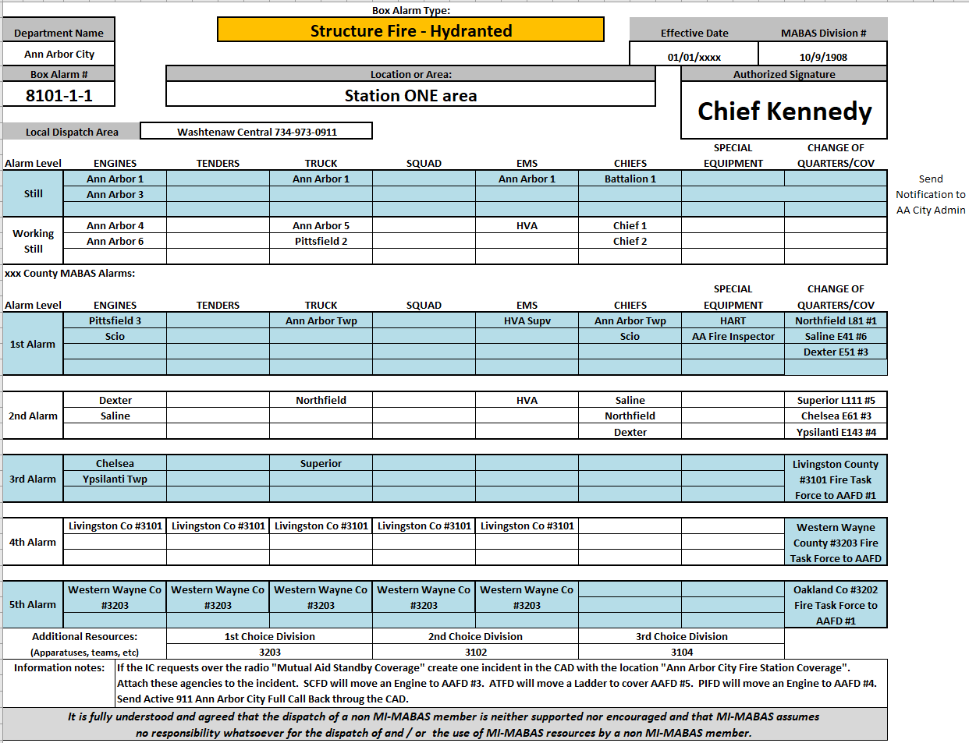

Ypsilanti City example Confined Space
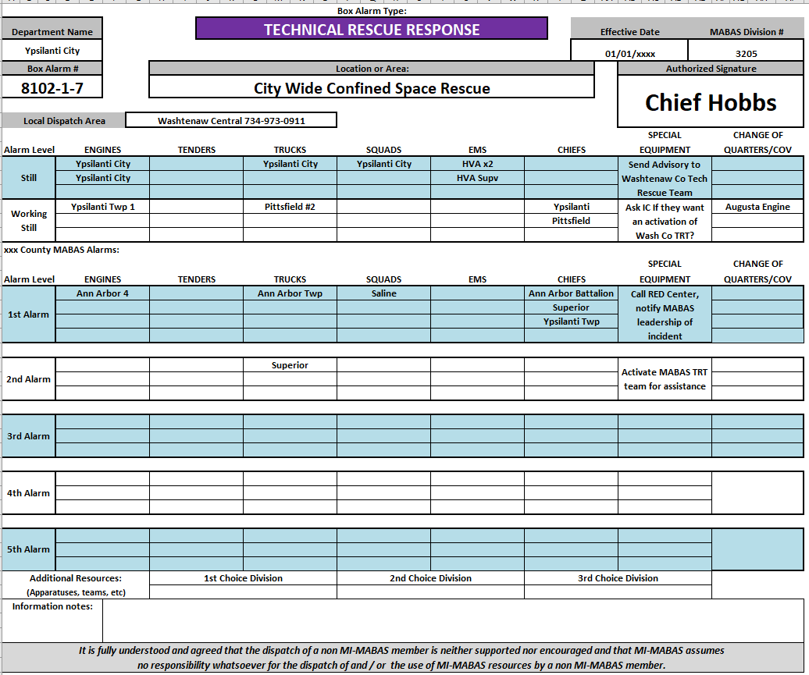

Ypsilanti City example Rope rescue
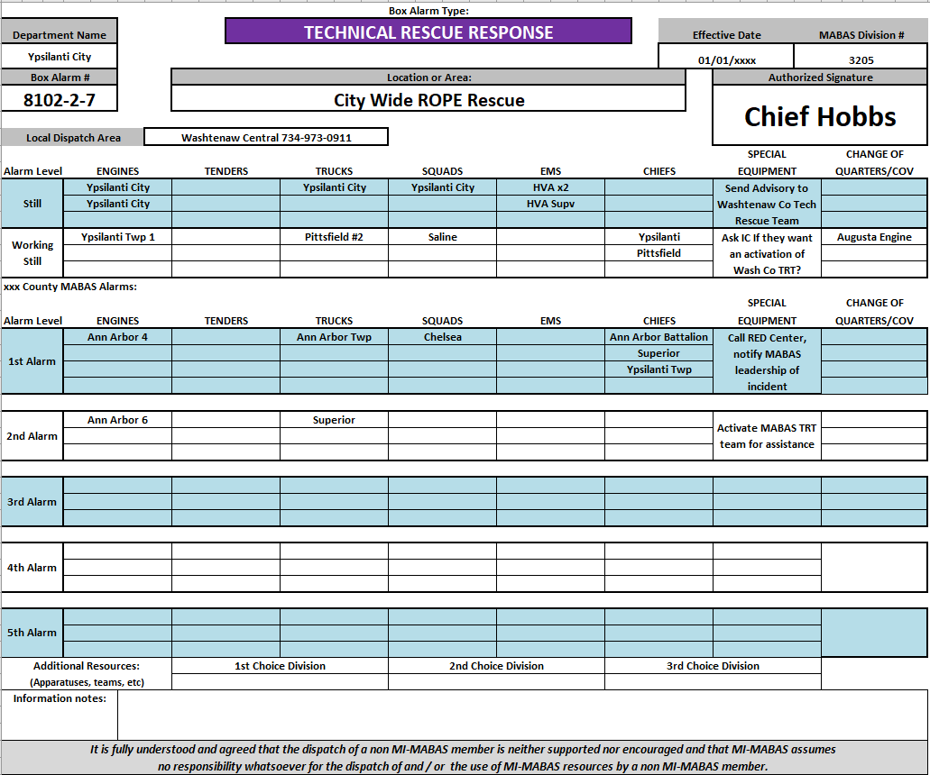

Superior example Target Hazard
